**GROUP NUMBER:** 19

**NAMES OF GROUP MEMBERS:** Farasi Makanaka 43779433, Hlumbene Neo 42452422, Montjane Amogelang 41595270, Sibanda Michel 38780089, Xhinela Solihle 42273188

**SHORT DESCRIPTION FOR THE TOPIC:** This is a system for Tawanda Orphanage, that keeps records of children and the donations they receive.

**PROGRAMMING LANGUAGE:** C#

**DBMS:** SQL Server Management Studio

**USERNAMES AND PASSWORDS:** Linda@03 and #Man0003

Mpho@66 and #Admin66

**SCOPE**

* Maintain Children
* Maintain Sponsors
* Maintain Donation Types
* Accept Children
* Child leaves home
* Receive Donation
* Request reports of Donations received per time period.
* Request reports of Children

**PHYSICAL DATA MODEL**

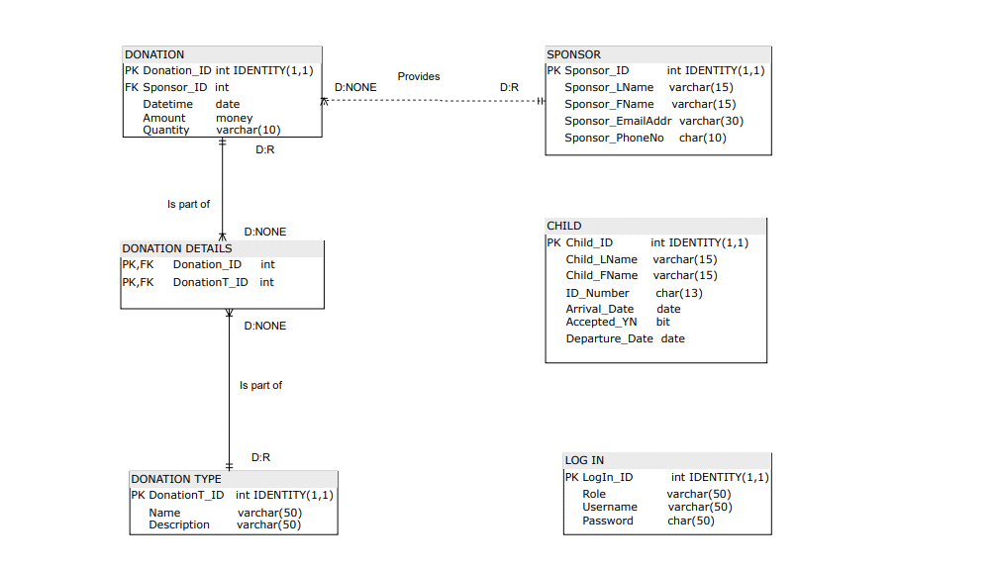

**PHYSICAL PROCESS MODEL**

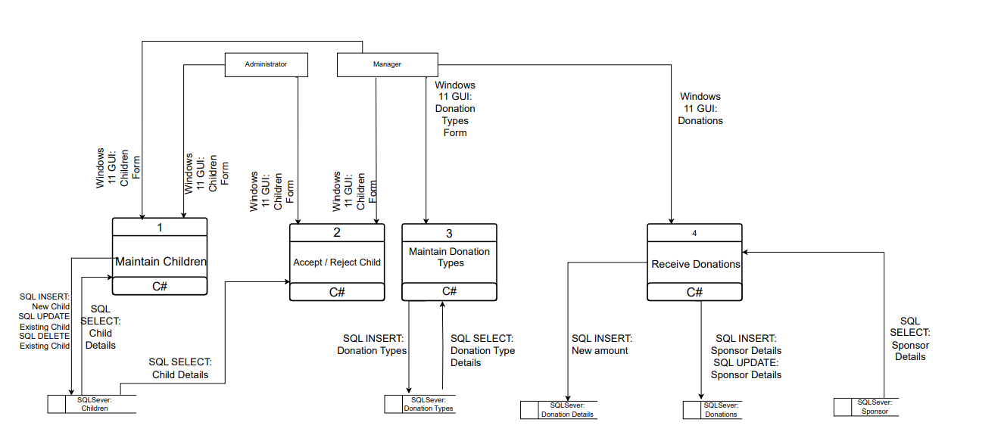

DATABASE SCHEMA

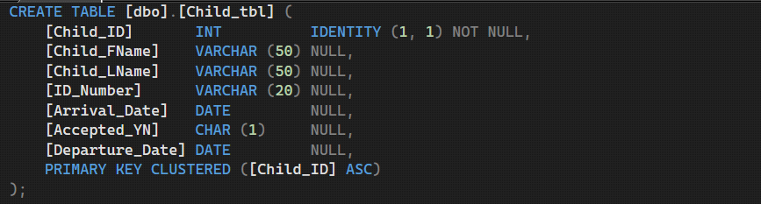

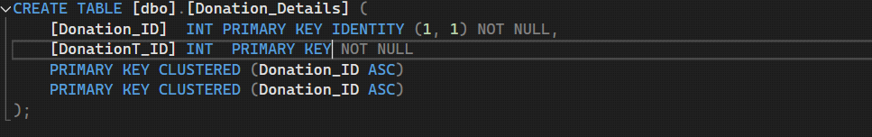

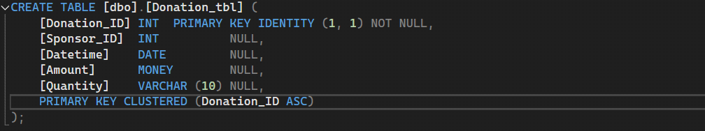

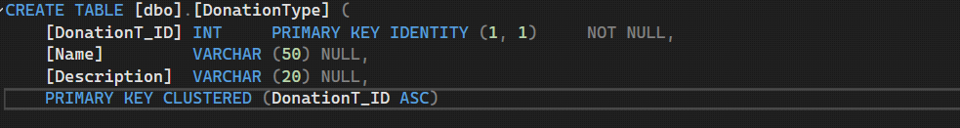

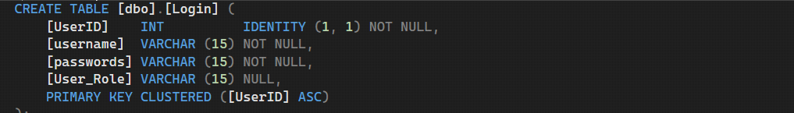

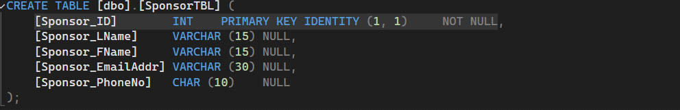

SQL USED

Creating the database tables (create)

• CREATE TABLE Child_tbl (

Child_ID int IDENTITY (1,1) PRIMARY KEY,

Child_LName varchar (15),

Child_FName varchar (15),

ID_Number char (13),

Arrival_Date date,

Accepted_YN bit,

Departure_Date date

);

• CREATE TABLE SponsorTBL (

Sponsor_ID int IDENTITY (1,1) PRIMARY KEY,

Sponsor_LName varchar (15),

Sponsor_FName varchar (15),

Sponsor_EmailAddr varchar (30),

Sponsor_PhoneNo char (10)

);

• CREATE TABLE Donation_tbl (

Donation_ID int IDENTITY (1,1) PRIMARY KEY,

Sponsor_ID int FOREIGN KEY REFERENCES SponsorTBL (Sponsor_ID),

Datetime date,

Amount money,

Quantity varchar (10)

);

• CREATE TABLE Donation_Details (

Donation_ID int IDENTITY(1,1) PRIMARY KEY ,

DonationT_ID int IDENTITY(1,1) PRIMARY KEY

);

• CREATE TABLE Donation Type (

DonationT_ID int IDENTITY (1,1) PRIMARY KEY,

Name varchar(50)

Description varchar (50)

);

**Maintaining All tables in the database (insert, update and delete)**

**Children Table**

SELECT * FROM Child_tbl

SELECT * FROM Child_tbl WHERE ID_Number < '1612301111111'

SELECT * FROM Child_tbl WHERE ID_Number BETWEEN '1512301111111' AND '0712301111111'

SELECT * FROM Child_tbl WHERE ID_Number > '1512301111111'

INSERT INTO Child_tbl(Child_LName, Child_FName, ID_Number, Arrival_Date, Accepted_YN) VALUES (@FName, @LName, @IDNumber, @dateArrived, @IsAccepted)

UPDATE Child_tbl SET Departure_Date = @departureDate WHERE Child_ID = @Child_ID

SELECT * FROM Child_tbl WHERE Child_ID = @Child_ID

SELECT Child_ID, Child_FName, Child_LName, Departure_Date FROM Child_tbl

DELETE FROM Child_tbl WHERE Child_ID = @Child_IDdel

SELECT Child_ID, Child_FName, Child_LName, Departure_Date FROM Child_tbl WHERE Child_ID = @Child_ID

SELECT * FROM Donation_tbl

SELECT * FROM Donation_tbl WHERE Datetime < '2017-12-29'

SELECT * FROM Donation_tbl WHERE Datetime > '2018-12-29'

INSERT INTO Donation_tbl(Datetime, Amount, Quantity) VALUES(@dateReceived,@num,@qty)

UPDATE SponsorTBL SET Sponsor_LName = @Sponsor_LName, Sponsor_FName = @Sponsor_FName, Sponsor_EmailAddr = @Sponsor_EmailAdd, Sponsor_PhoneNo = @Sponsor_PhoneNo WHERE Sponsor_ID = @Sponsor_ID

SELECT * FROM SponsorTBL WHERE Sponsor_ID = @Sponsor_ID

SELECT DISTINCT Name FROM DonationType

SELECT * FROM SponsorTBL WHERE Sponsor_ID = @Sponsor_ID

SELECT * FROM Login WHERE username = '" + txtUser.Text + "'AND passwords = '" + txtPassword.Text + "'

INSERT INTO DonationType(Name, Description) VALUES ('{txtDonationTA.Text}', '{txtDonationDescr.Text}')

UPDATE Child_tbl SET Departure_Date = @departureDate WHERE Child_ID = @Child_ID

**Querying the database e.g. for reports (select)**

SELECT * FROM DonationType WHERE donationType LIKE @DonationType

DELETE FROM DonationType WHERE DonationT_ID = @DonationT_Del

SELECT * FROM DonationType

SELECT DonationT_ID, Name, Description FROM DonationType WHERE DonationT_ID = @DonationT_ID

SELECT DATEPART(year,Datetime) AS YEAR , DATEPART(month,Datetime) AS Month,SUM(Amount ) AS Monetary,COUNT(Quantity) AS NonMonetary FROM Donation_tbl WHERE Datetime >= @StartDate AND Datetime <= @EndDate Group BY DATEPART(year,Datetime),DATEPART(month,Datetime)ORDER BY Year,Month

SELECT DATEPART(year,Datetime) AS YEAR , DATEPART(month,Datetime) AS Month,SUM(Amount)AS Monetary, COUNT (Quantity)AS NonMonetary FROM Donation_tbl WHERE Datetime >= @StartDate AND Datetime <= @EndDate Group BY DATEPART(year,Datetime),DATEPART(month,Datetime)ORDER BY Year,Month

SELECT DATEPART(year,Datetime) AS YEAR ,SUM(Amount)AS Monetary,COUNT(Quantity) AS NonMonetary FROM Donation_tbl WHERE Datetime >= @StartDate AND Datetime <= @EndDate Group BY DATEPART(year,Datetime) ORDER BY Year

SELECT DATEPART(month,Datetime) AS Month,SUM(Amount)AS Monetary,COUNT(Quantity) AS NonMonetary FROM Donation_tbl WHERE Datetime >= @StartDate AND Datetime <= @EndDate Group BY DATEPART(month,Datetime)ORDER BY Month

SELECT Child_ID,Child_FName,Child_LName,ID_Number,Arrival_Date,Accepted_YN,Departure_Date FROM Child_tbl

SELECT Child_ID,Child_FName,Child_LName,ID_Number,Arrival_Date,Accepted_YN,Departure_Date FROM Child_tbl WHERE Accepted_YN = 1

SELECT Child_ID,Child_FName,Child_LName,ID_Number,Arrival_Date,Accepted_YN,Departure_Date FROM Child_tbl WHERE Arrival_Date >= @Arrival_Date

SELECT * FROM Child_tbl ORDER BY Arrival_Date ASC

SELECT * FROM Child_tbl ORDER BY Arrival_Date DESC

MAINTAINING CHILD ENTITY FOR CHILDREN FORM

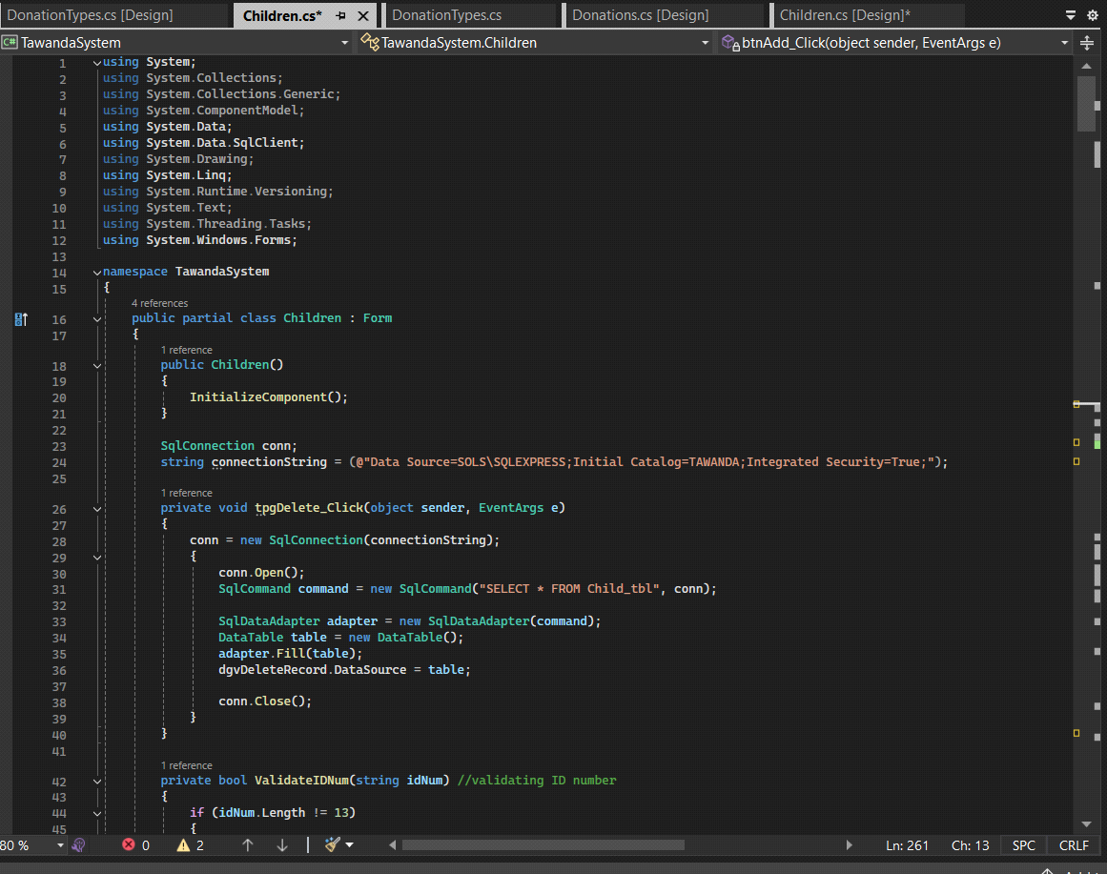

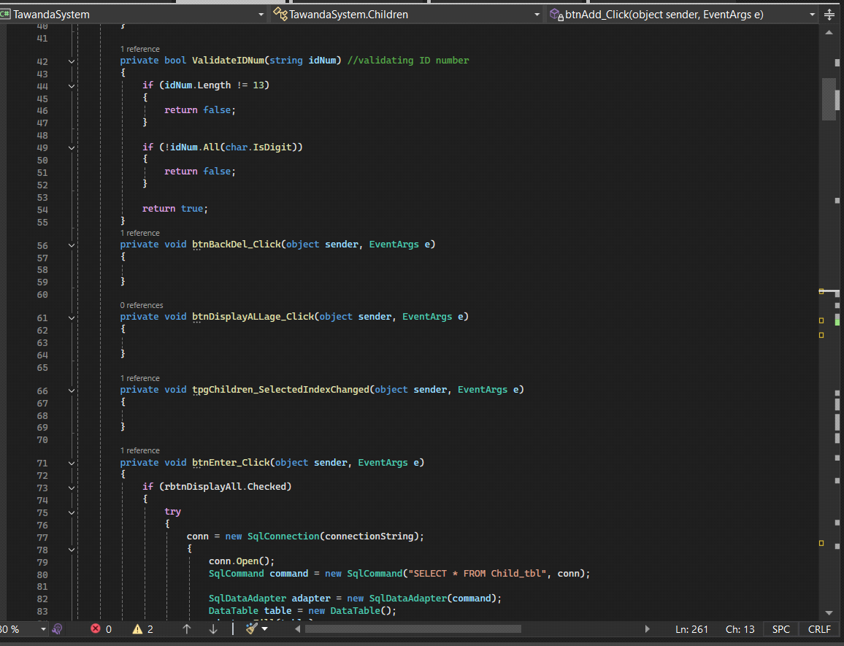

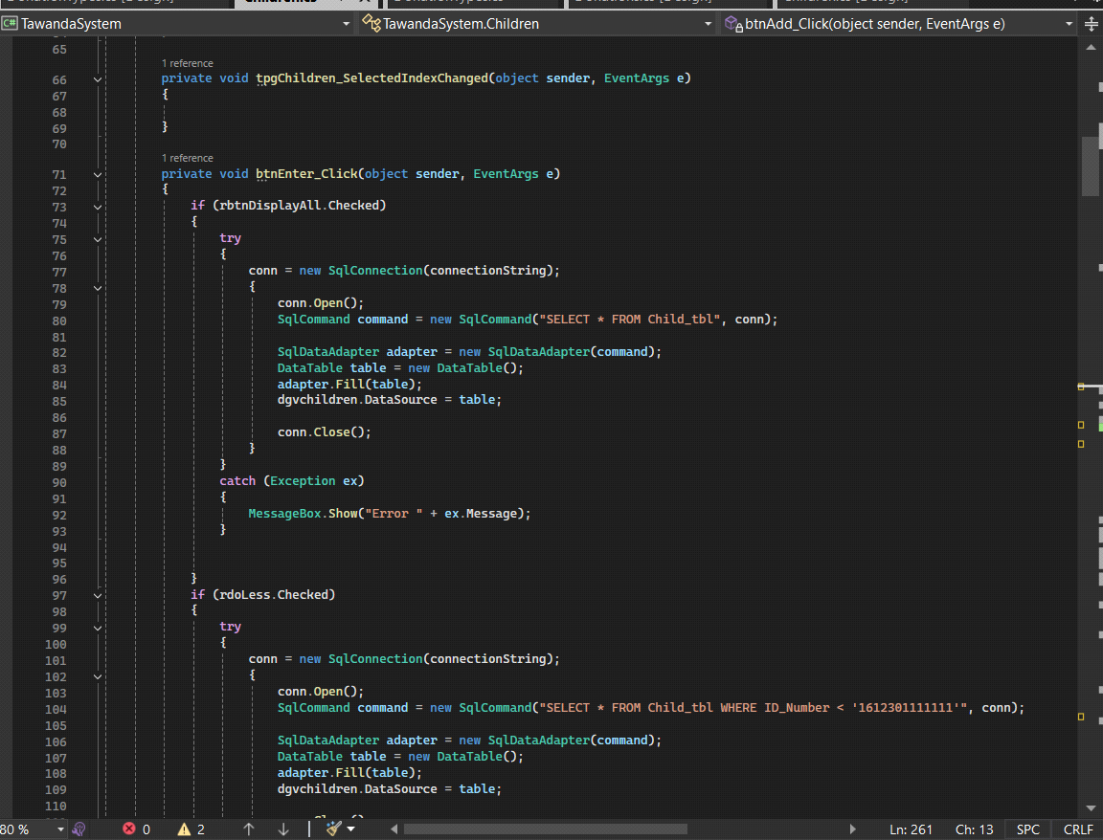

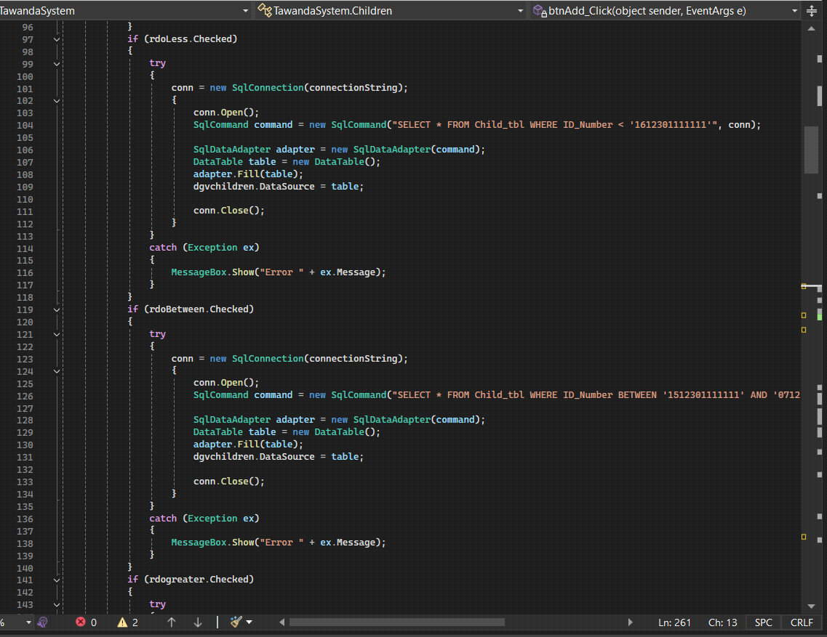

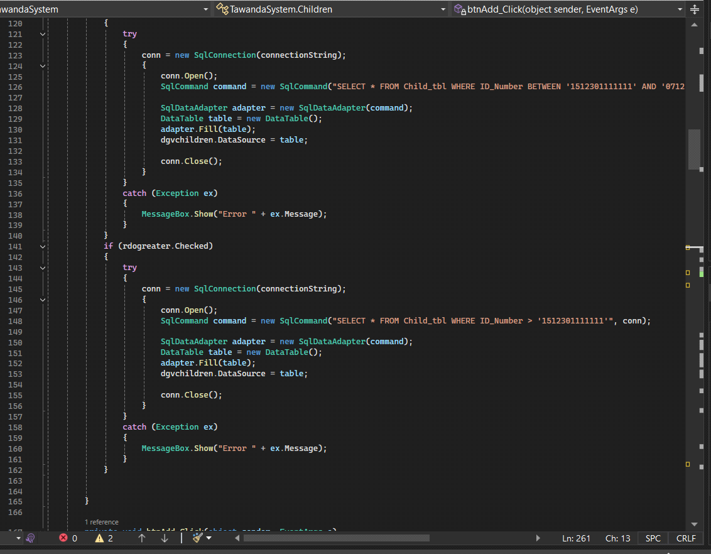

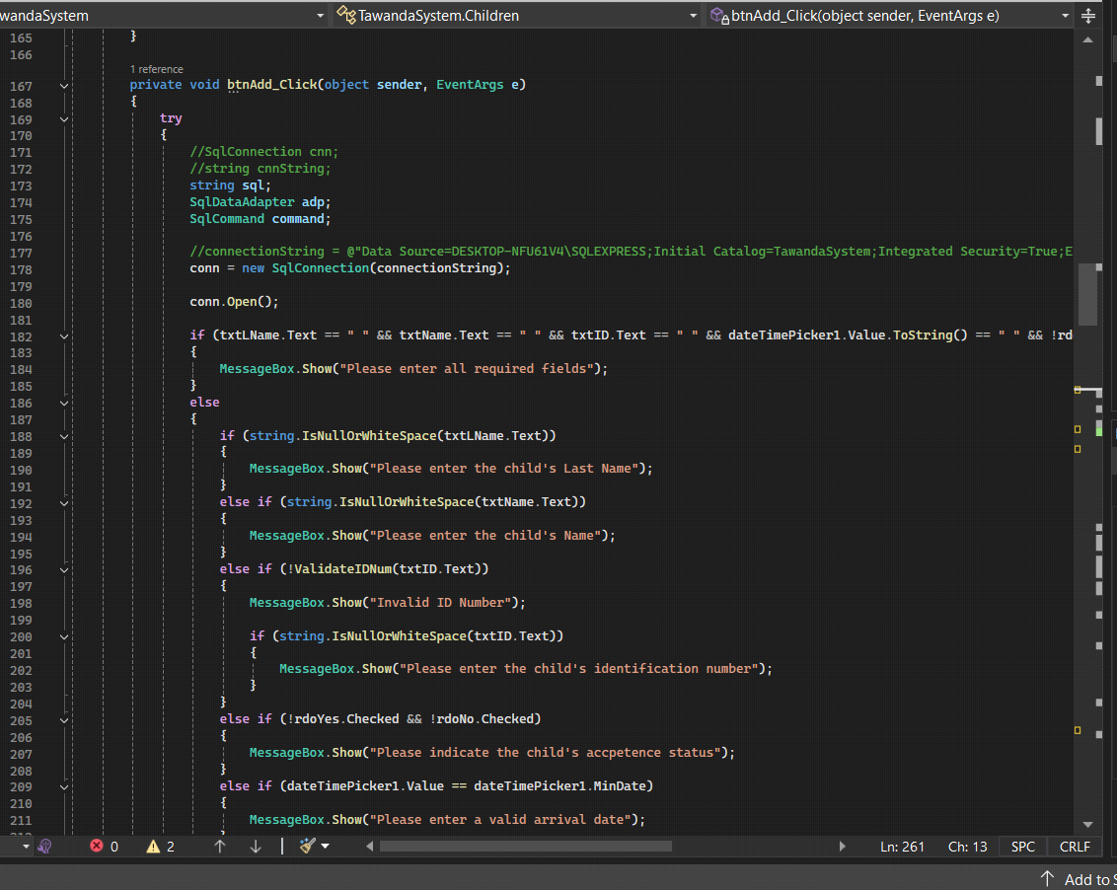

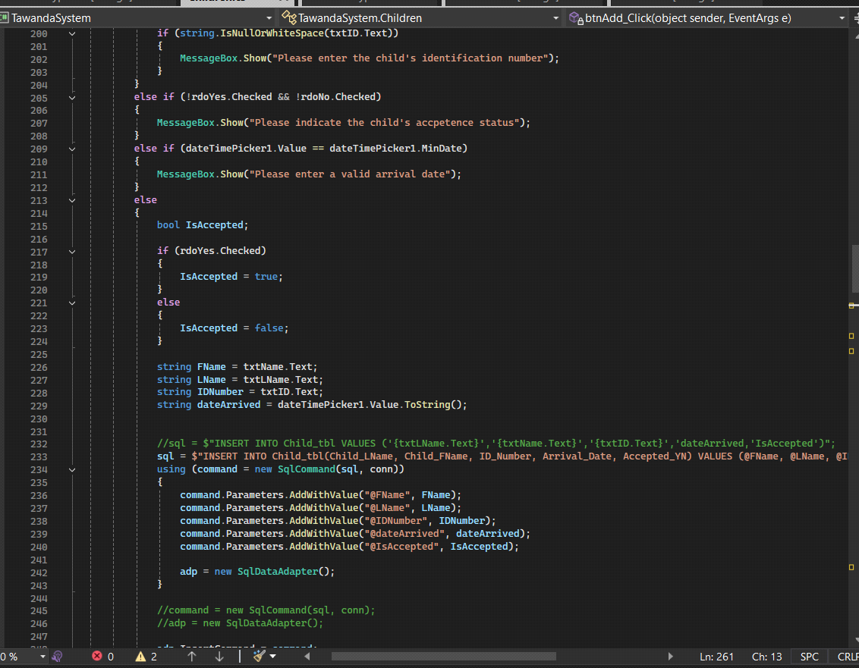

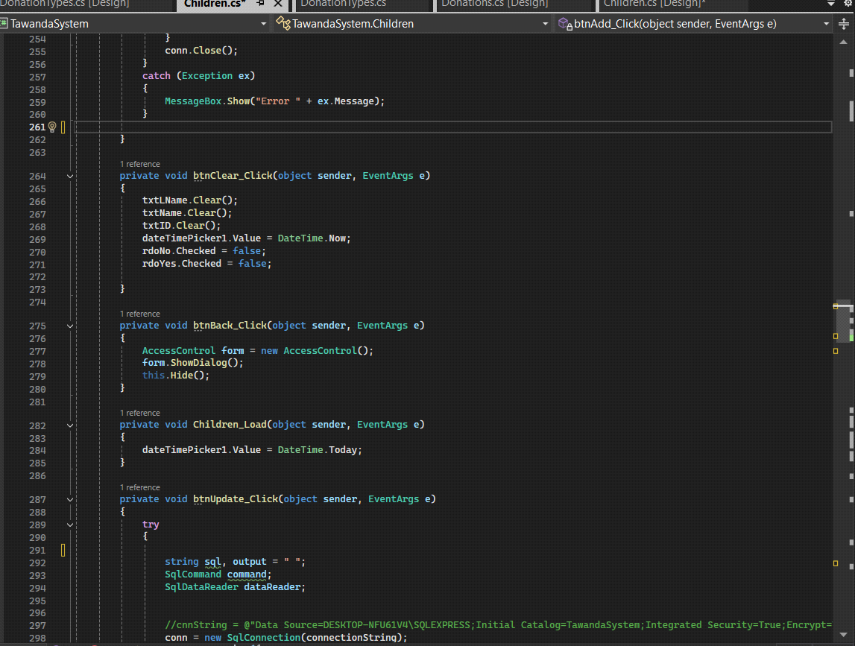

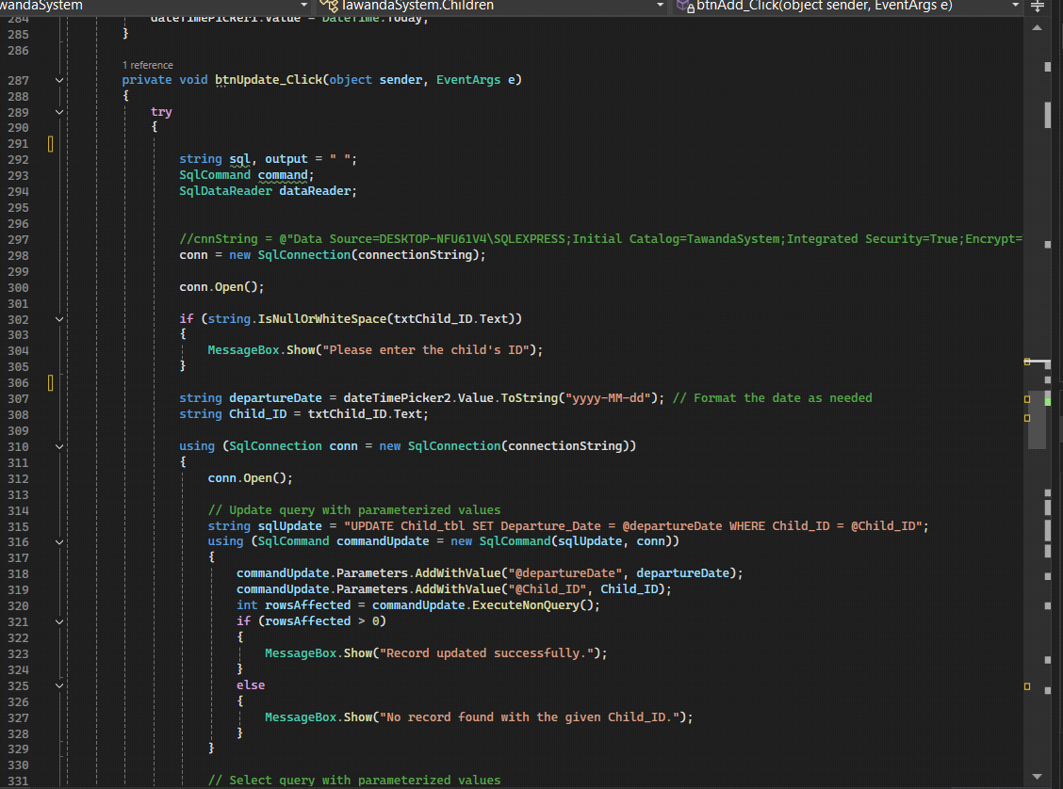

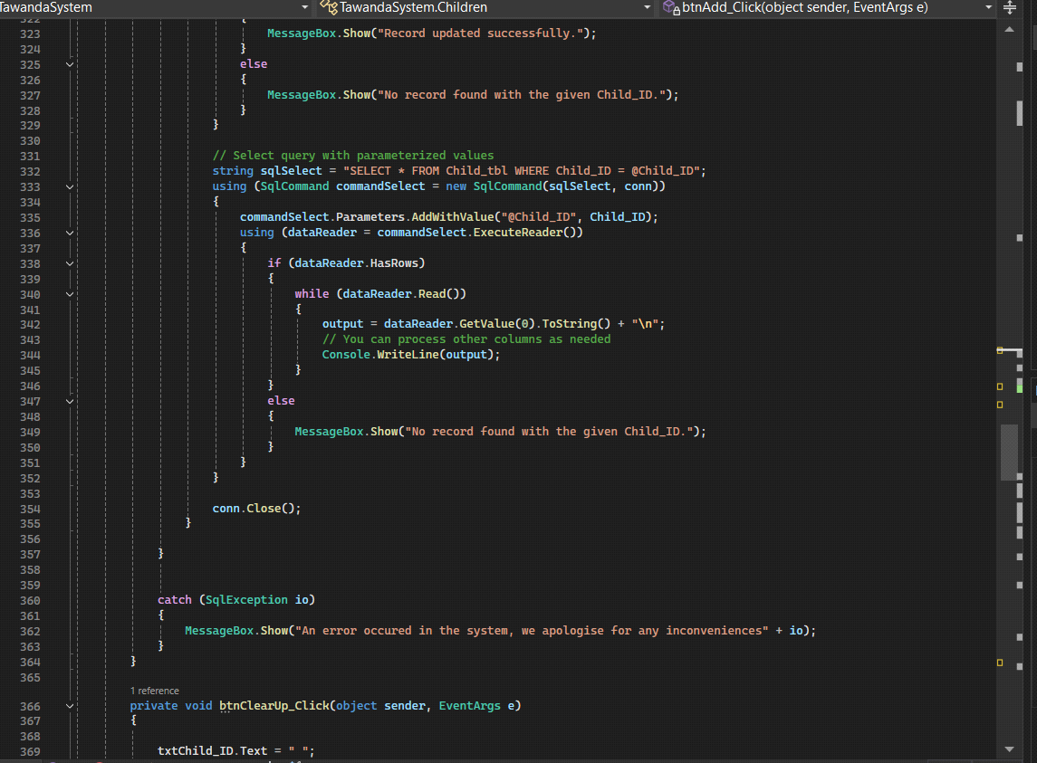

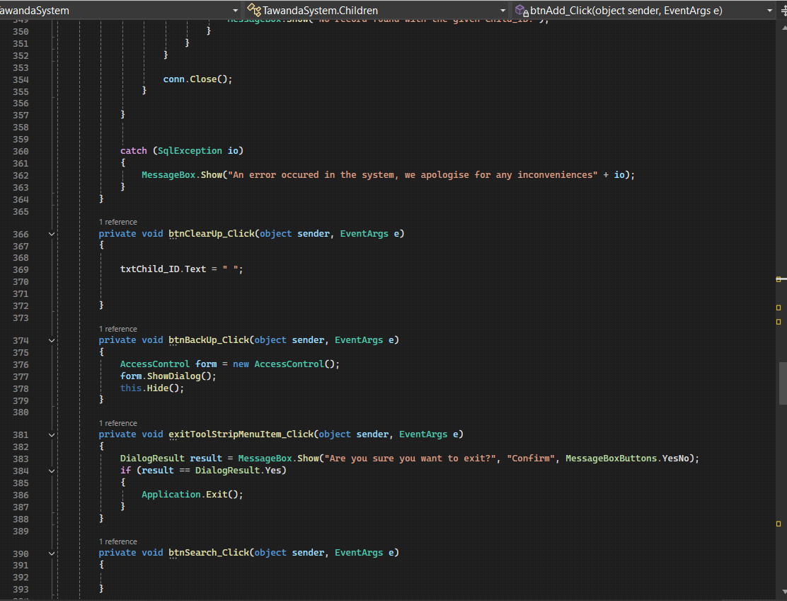

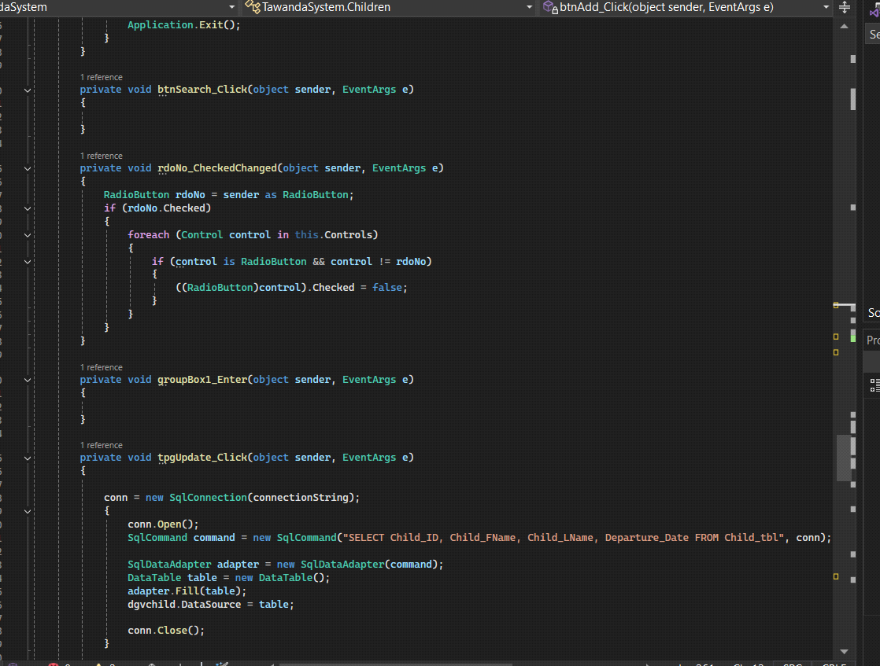

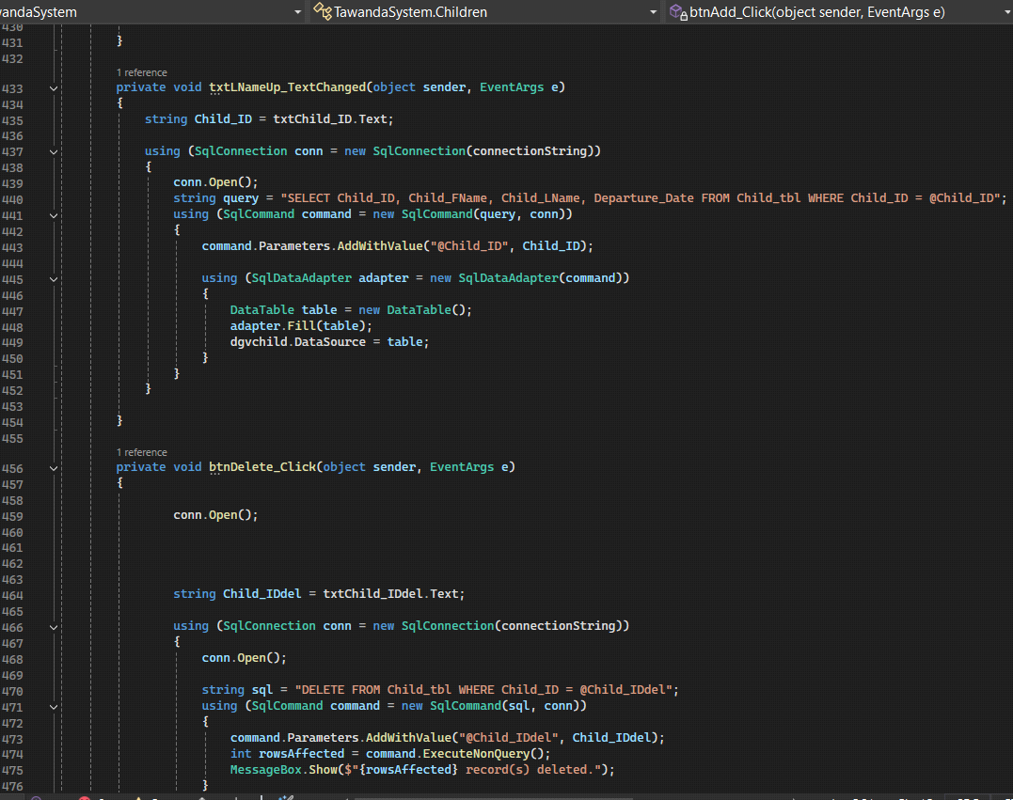

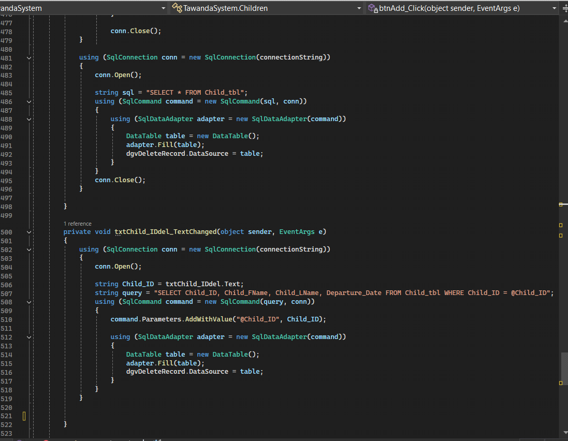

REPORTS

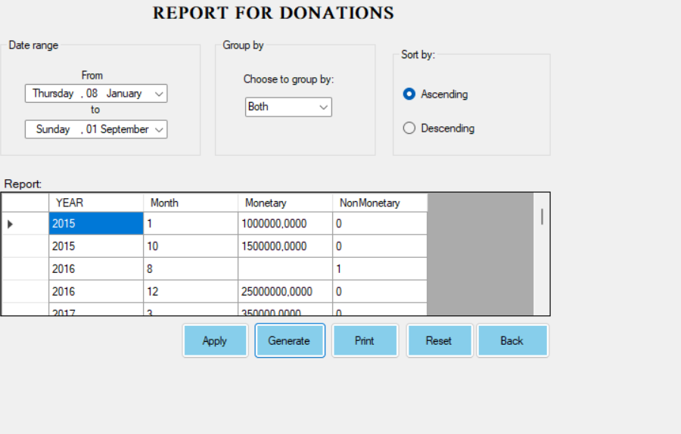

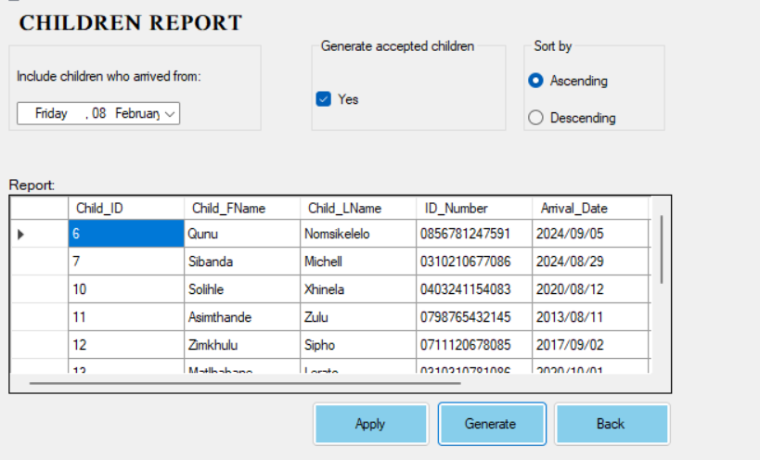

USER MANUAL FOR TAWANDA HOME OF LOVE

Congratulations on purchasing our system! This manual will guide you through the installation process.

**Steps to follow to get the system Installed:**

-**Pre-installation Requirements**:

* Make sure you have the necessary hardware and software requirements.
* Read the manual carefully before starting the installation.

-**Installation steps**:

* Insert installation media (CD, DVD, or USB drive) into your computer.
* Follow the on-screen instructions to start the installation
* Accept the license agreement & select the installation location.
* Choose the components to install and select the installer type (e.g., typical, custom)
* Enter any required information (e.g. username, password, network settings)
* Wait for the installation to be completed.
* Restart your computer when prompted.

-**Post-installation steps**

* Activate the system
* Configure any additional settings (e.g. network, security).
* Test the system to ensure it is working correctly.

**Troubleshooting**

-**Hardware requirements**:

* Processor: Intel core is or equivalent.
* Memory: 8GB ram or more.
* Storage: 256 GB hard drive or solid-state drive.
* Display: 1024 × 768 resolution or higher.
* Network: Ethernet or Wi-Fi connectivity.

-**software requirements**:

* Operating system: windows 11
* .NET framework
* SQL server

-**Database Requirements**:

* Database management

**System: Microsoft SQL server**

* Database size: 500 MB (minimum)
* Database user: db_owner role

-**Network Requirements**:

* Network protocol: TCP/ID
* Port requirements: 1433(SQL server), 80(HTTP)
* Firewall configuration: allow incoming connections on specified ports.

DETAILED DIARY

|  |  |  |  |
| --- | --- | --- | --- |
| **Group Member Name** | **Time spent on project** | **Overtime spent on project** | **Total time spent on project** |
| Farasi Makanaka | 3 hours*3 days*7 weeks | 51 hours | 114 hours |
| Hlumbene Neo | 3 hours*3 days*7 weeks | 51 hours | 114 hours |
| Montjane Amogelang | 3 hours*3 days*7 weeks | 51 hours | 114 hours |
| Sibanda Michel | 3 hours*3 days*7 weeks | 51 hours | 114 hours |
| Xhinela Solihle | 3 hours*3 days*7 weeks | 51 hours | 114 hours |

**GITHUB SCREEN PRINTS**

